Тесты:

Solving Programming Problems

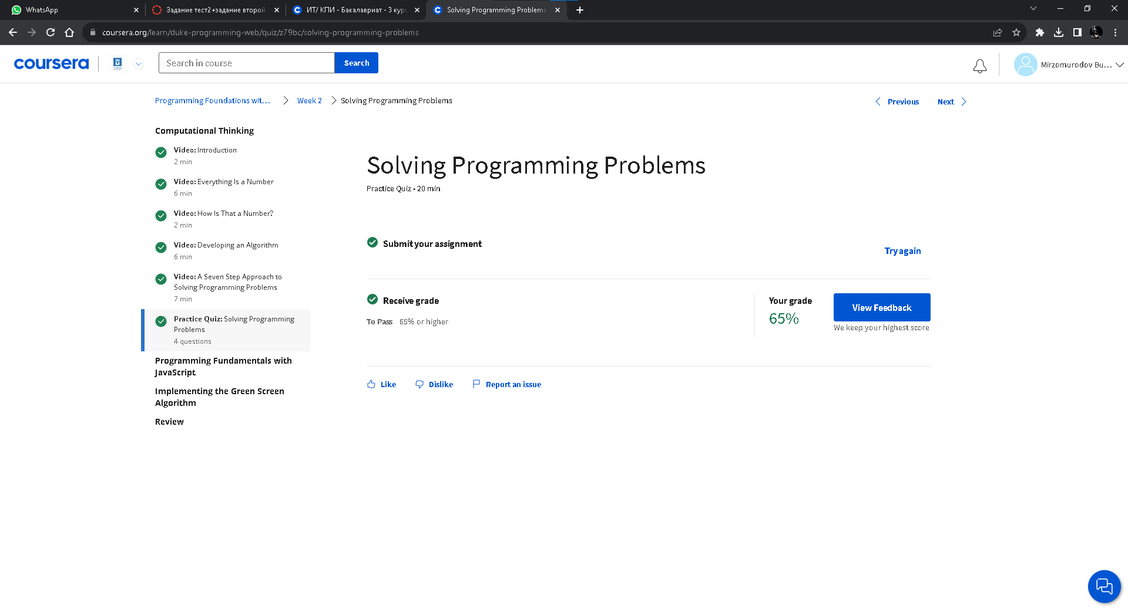Variables, Methods and Functions

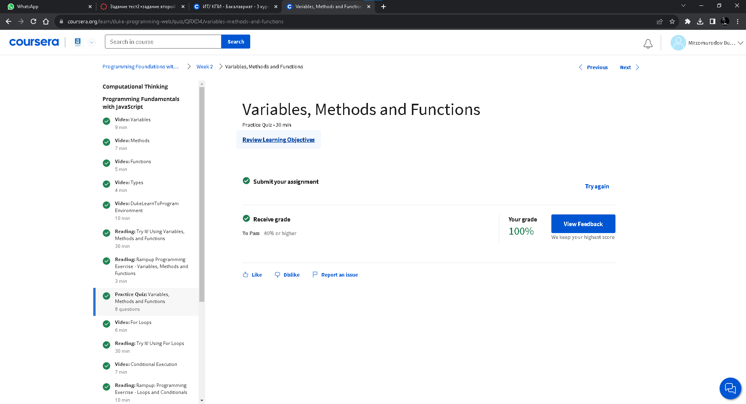Loops and Conditionals

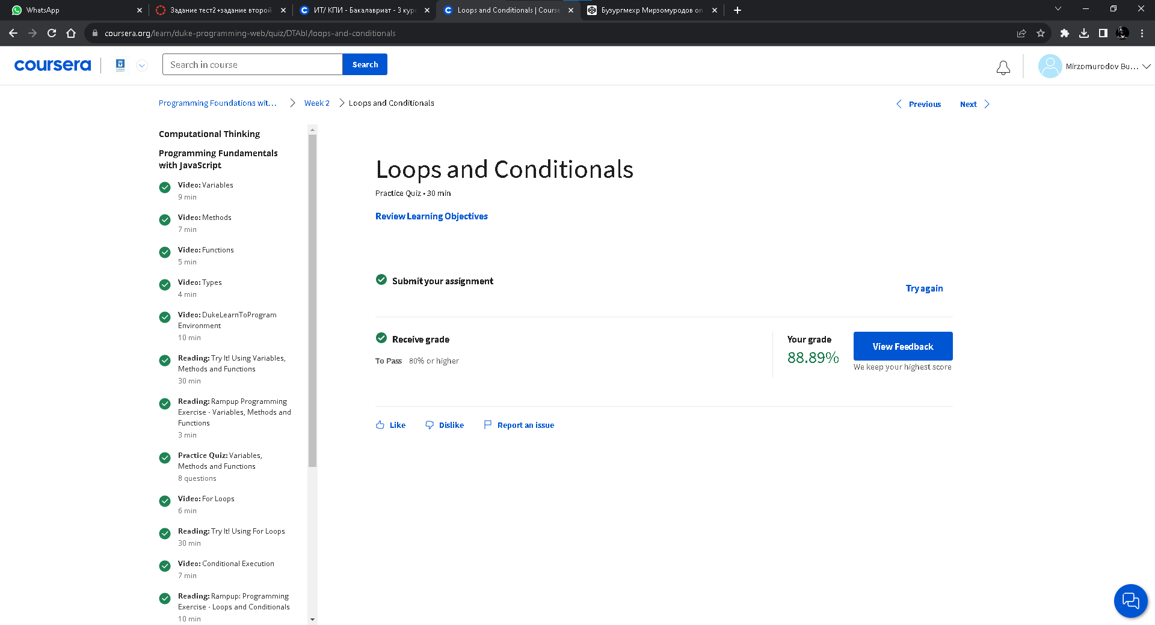

# Modifying Images with JavaScript

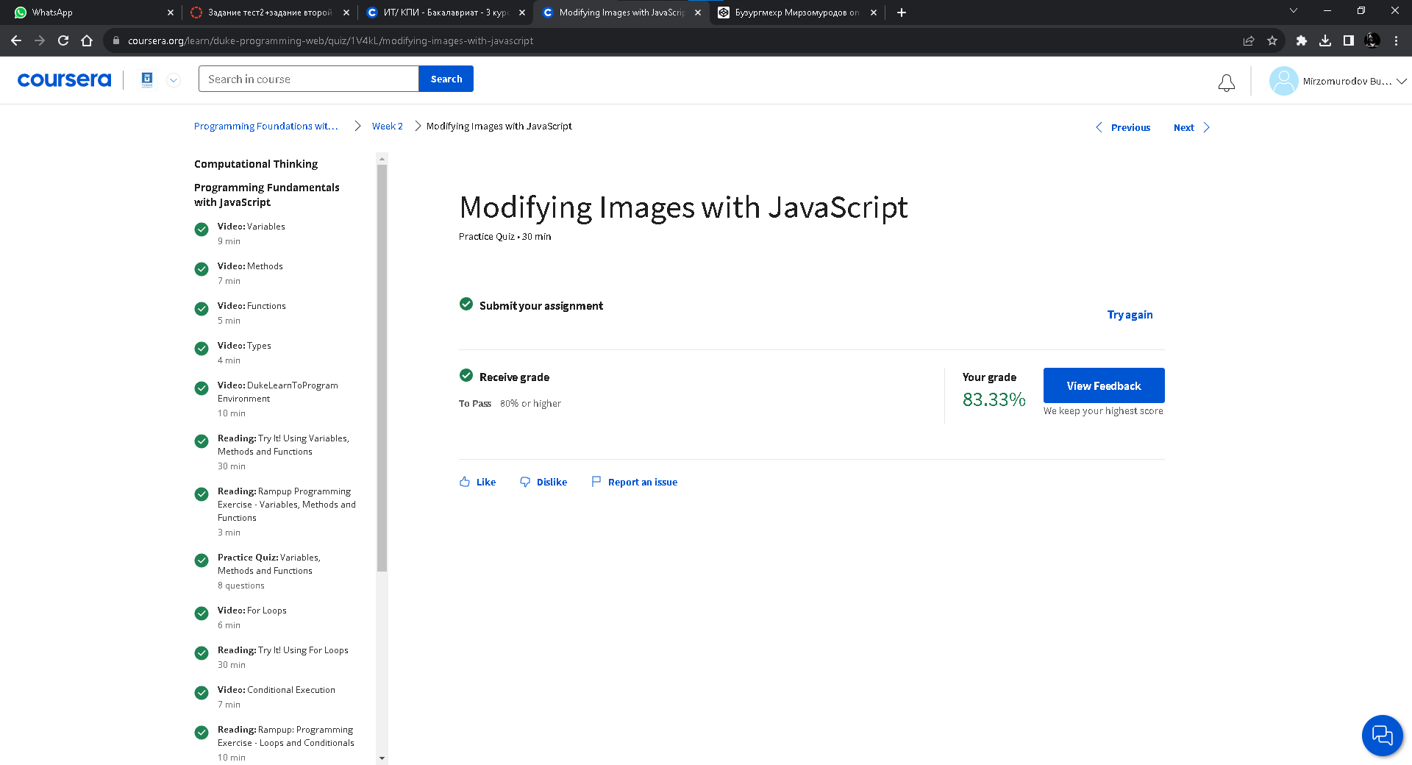

# Debugging Your Code

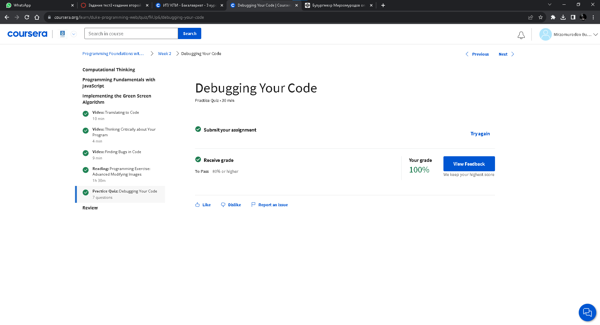

Задании:

<https://codepen.io/ylpkbcjx-the-solid>